**Text-to-Image Generation with Stable Diffusion**

**Project Aim**

The project aims to build an efficient, interactive application that converts text descriptions into high-quality images using the Stable Diffusion XL (Turbo) model. Leveraging advanced deep learning techniques and the power of Gradio for user interaction, the tool enables users to visualize their ideas in the form of images. The project focuses on creating a user-friendly application with advanced customization options, making it suitable for various creative and professional applications.

**Stable Diffusion XL (Turbo) Model Overview**

Stable Diffusion XL (Turbo) is an advanced version of the original Stable Diffusion model, designed to enhance image quality and generation efficiency. It builds upon the success of the earlier model by incorporating cutting-edge deep learning techniques and large-scale pre-training on diverse datasets, aiming to generate high-fidelity and detailed images from textual descriptions. The Turbo variant is optimized for faster inference and higher-quality results, mainly when dealing with complex prompts or large-scale photos.

**Key Enhancements in Stable Diffusion XL (Turbo):**

1. **Improved Quality and Details**

Stable Diffusion XL (Turbo) leverages improved diffusion models, enhanced generative adversarial networks (GANs), and advanced denoising techniques, resulting in sharper, more realistic, and detailed image outputs compared to earlier versions. The focus is on enhancing fine details like textures, lighting, and complex structures.

1. **Memory-Efficient Attention (xFormers)**

The Turbo variant includes xFormers memory-efficient attention mechanisms, optimizing GPU memory usage and accelerating inference. This ensures high-performance generation even on limited hardware configurations.

1. **Expanded Capabilities for Larger Image Sizes**

The model supports image dimensions up to 1024x1024 pixels, enabling the generation of highly detailed and large-scale images suitable for professional applications, creative projects, and concept design.

1. **High-Quality Text-to-Image Mapping**

The Stable Diffusion XL (Turbo) benefits from pre-training on extensive datasets, enhancing the model's understanding of complex text prompts. This results in a more accurate and coherent generation of images that closely adhere to user-provided descriptions.

1. **Customizable Control Parameters**

The model allows for adjustable parameters like guidance scale and number of inference steps, giving users control over the degree of adherence to the text prompt versus creative freedom.

1. **Robust and Scalable Pre-Trained Model**

By pre-training on vast datasets, the Turbo variant excels in handling various visual styles and scenes, from artistic renderings to realistic depictions, ensuring versatility for different use cases.

**Key Features of the Gradio Interface Using Stable Diffusion XL (Turbo):**

1. **Prompt and Negative Prompt**

Users can input descriptive text to generate the desired image, while the negative prompt helps filter out unwanted elements to refine the output.

1. **Random Seed or Fixed Seed Generation**

Users can randomize or fix the seed for reproducibility, allowing for consistent or diverse results based on their needs.

1. **Image Dimensions**

The model supports flexible image dimensions (256 to 1024 pixels), enabling users to create everything from small thumbnails to high-resolution images.

1. **Guidance Scale and Inference Steps**

These parameters control how much the text prompt influences the output, providing fine-tuning over the balance between creativity and fidelity to the input.

1. **Efficient GPU/CPU Support**

The model optimizes GPU and CPU environments, ensuring high performance even in resource-constrained scenarios.

**Results**

Users can generate stunning visuals from simple text descriptions. For example:

* **Prompt:** *"Sunset in Hawaii, cold color palette, muted colors, detailed, 8k"*
* **Prompt:** *"A dog catching a baseball"*

The customization options ensure users can fine-tune the results for specific applications, from artistic projects to concept visualizations.

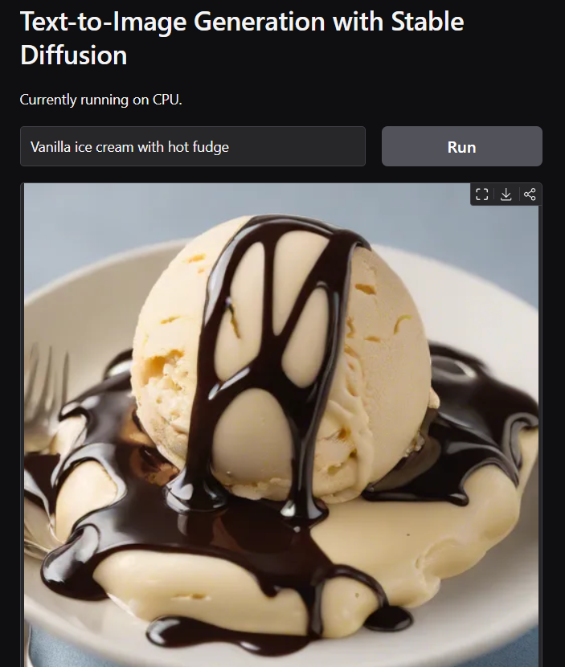

*Figure 1: Gradio Interface showcasing text-to-image generation results.*

**How It Works**

1. The user enters a text prompt describing the desired image.
2. Optional parameters like negative prompts, image dimensions, and guidance scale can be set.
3. The application processes the input through the Stable Diffusion model using a DiffusionPipeline from Hugging Face.
4. The generated image is displayed in real-time, ready for download or further exploration.

**Project Accessibility**

The project is hosted on GitHub and Hugging Face Spaces for public access:

* [**GitHub Repository**](https://github.com/srikta/text-to-image.git)
* [**Hugging Face Demo**](https://huggingface.co/spaces/Sourikta/Text_To_Image)

**Conclusion**

This project successfully bridges the gap between textual imagination and visual creation. Providing a robust, customizable, and interactive platform empowers users to bring their ideas to life effortlessly. Whether for creative exploration or professional use cases, this tool offers a powerful solution for text-to-image generation.